Jason Palmeri

CSD200

Assignment 10.3

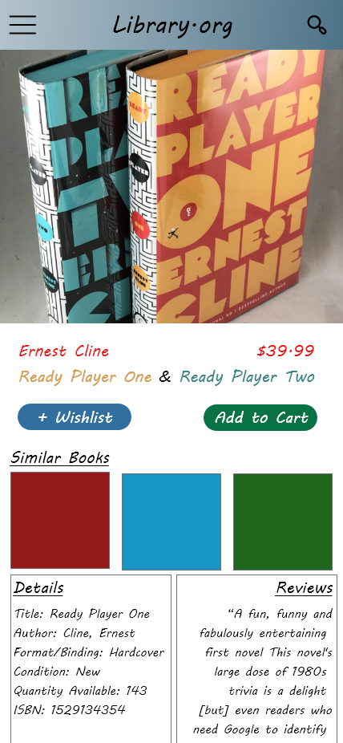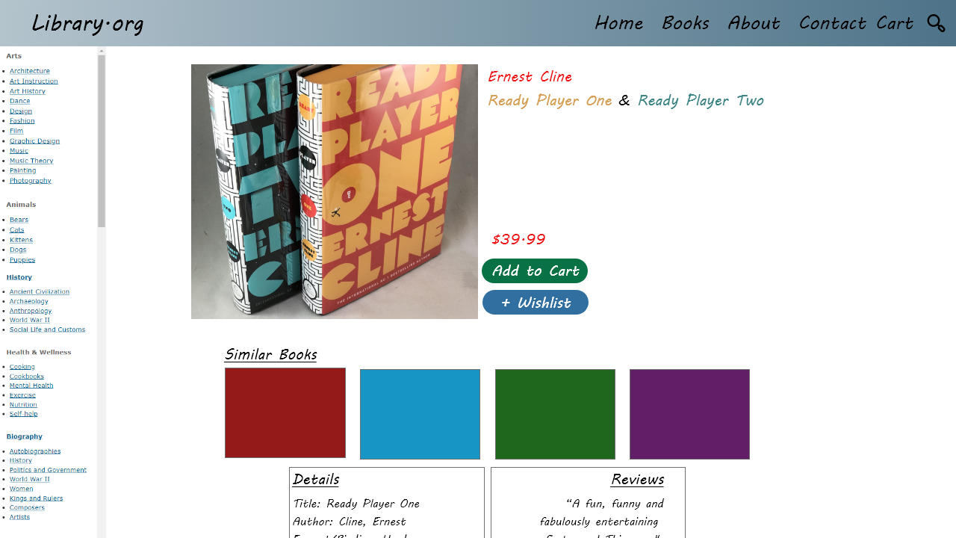

When we go from mobile to desktop, we are just creating more white space, so for this one I decided to add more “similar books”, and to space out the title of the book and it's price. I also add the extended menu, and the left navigation bar

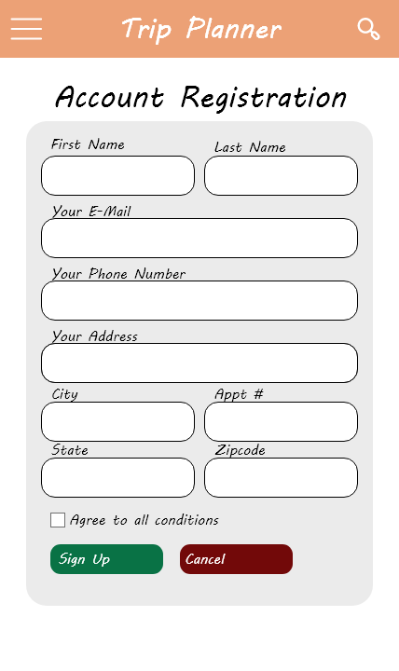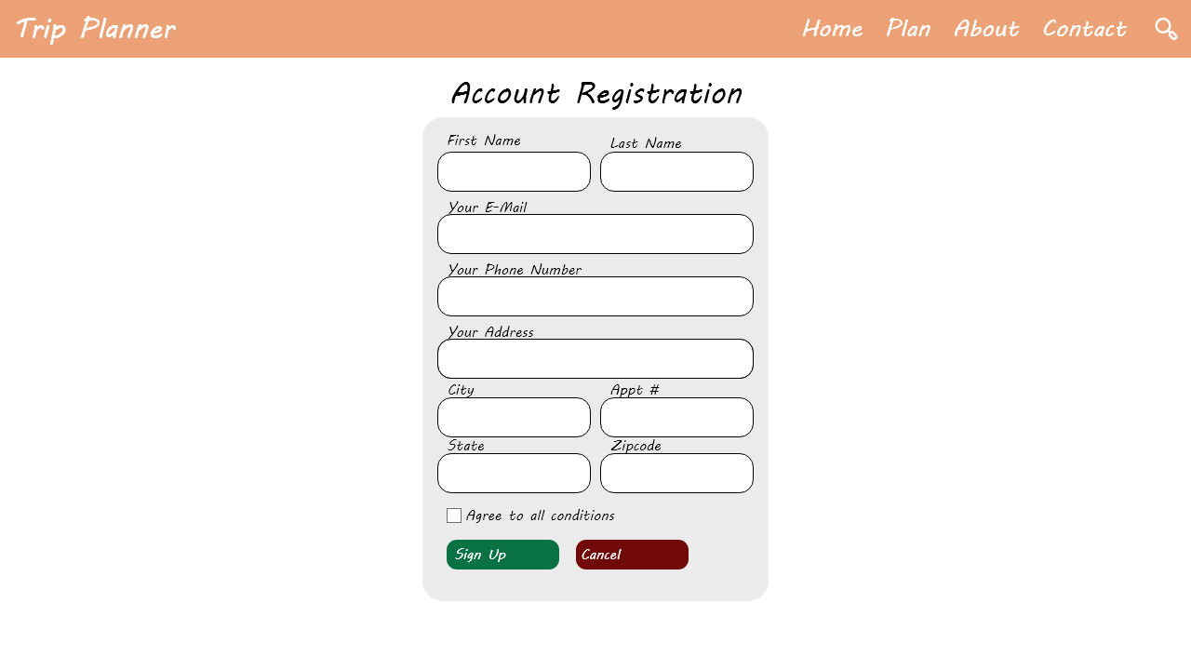

For the registration form, I think that in essence it should always be in a tinner format, so no matter what the size of the device, the form should be contained, else it looks like you are trying to fill empty space when it is unnecessary.